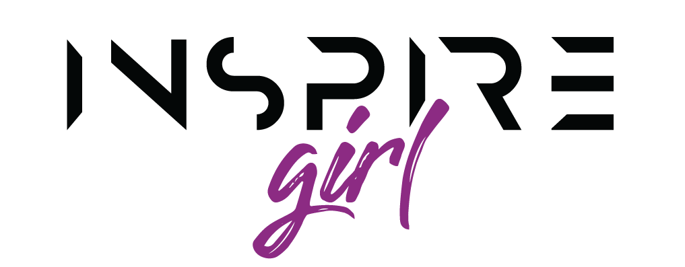
HOSTED BY NEW LIFE COMMUNITY CHURCH
REGISTRATION FORM
Inspire Girl is a 6-week course. Our first session will be held on Wednesday, May 5 and the rest of the sessions will run on Mondays, starting May 10, 2021. All sessions will run from 3:30 – 5:00 or 5:30 (time will depend on what is needed by participants).
Please fill in the registration form and email it to ghacking@sasktel.net. Participants will be limited to 30. Covid-19 rules will be enforced. All girls are required to wear a mask.
Name: _____________________________ Date of Birth: ______________________
Phone No: ____________________
Cell No: ______________________
Name of Parent/Guardian: ________________________________
Emergency Contact: _________________________

PARENTAL CONSENT
I _____________________________ as parent/guardian of aforementioned student, do give permission for _______________________ to attend Inspire Girl being held at Naicam New Life Community Church. I will not hold responsible the staff and volunteers New Life Community Church for any loss of property or harm resulting in injury. Any likeness (video or photo) taken of a Inspire Girl participant or any statement or comment made by a participant may be used in material published by New Life Community Church without compensation.

_______________________________________ _________________________________
Signature Date

For more information, please email Pastor Gwen at ghacking@sasktel.net or call (306) 874-8472.

Every girl who completes the course will receive a free book called STAND Secure.

